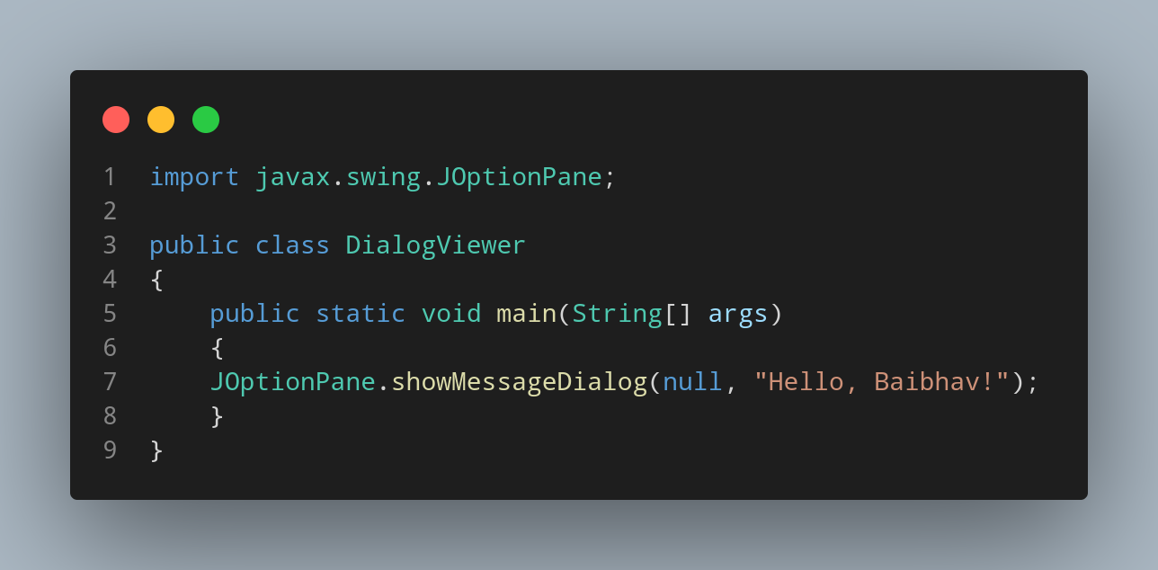
import javax.swing.JOptionPane;

public class DialogViewer
{
public static void main(String[] args)
{
JOptionPane.showMessageDialog(null, "Hello, Baibhav!");
}
}

